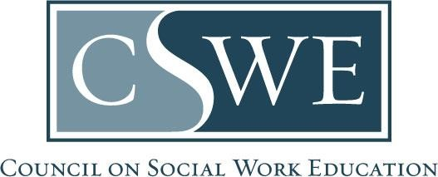
Commission on Accreditation (COA)
Department of Social Work Accreditation (DOSWA)
Baccalaureate and Master’s Social Work Program Accreditation

2022 EPAS
Form AS B5.0.1(d) | Public Reporting of Assessment Outcomes
University of Sioux Falls BSW Program 2024/2025 Report

Generalist Practice | Summary of Outcomes
Assessment Data Collected on: 2025

Competency | Competency:  Expected Level of Achievement Inclusive of All Instruments | Program Option 1  Outcomes:  BSW Program  n = (16)
Competency 1: Demonstrate Ethical and Professional Behavior | 80% | 96.8%
Competency 2: Advance Human Rights and Social, Racial, Economic, and Environmental Justice | 80% | 90.6%
Competency 3: Engage Anti-Racism, Diversity, Equity, and  Inclusion (ADEI) in Practice | 80% | 90.6%
Competency 4: Engage in Practice-informed Research and Research-informed Practice | 80% | 93.7%
Competency 5: Engage in Policy Practice | 80% | 96.8%
Competency 6: Engage with Individuals, Families, Groups, Organizations, and Communities | 80% | 93.7%
Competency 7: Assess Individuals, Families, Groups, Organizations, and Communities | 80% | 96.8%
Competency 8: Intervene with Individuals, Families, Groups, Organizations, and Communities | 80% | 96.8%
Competency 9: Evaluate Practice with Individuals, Families, Groups, Organizations, and Communities | 80% | 96.8%

